Rules for Group Assignments of Google Classroom

One student will be considered the group leader and owner of the document or slide presentation. It does not matter who this is.

Group Leader
- The group leader will need to open the group work document and click on the blue share button. The group leader will add the group members to the document to allow them to edit using their school @ebnet.org accounts.
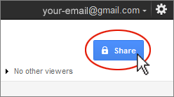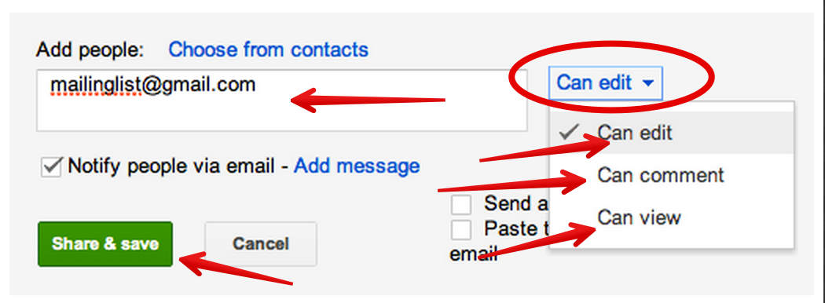
- The group leader will also need to modify the document title to add the names of the group members and your group COLOR to the end of the document title.

Group Members
- In Google Classroom the other group members will need to click on “OPEN” and click on the X on the right hand side of the attached documents.
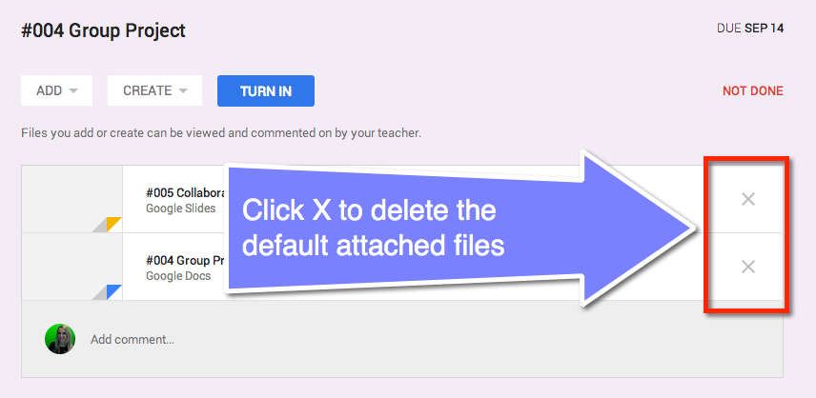

- Make sure the group agrees to changes, you work as a team. If you are working from different locations be sure to use proper netiquette. Make use of the suggestion mode and comments rather than just deleting what someone else wrote unless you are correcting spelling or in some cases formatting. Respond to each others comments. The suggestions are not considered part of the final draft and must be resolved before turning it in.
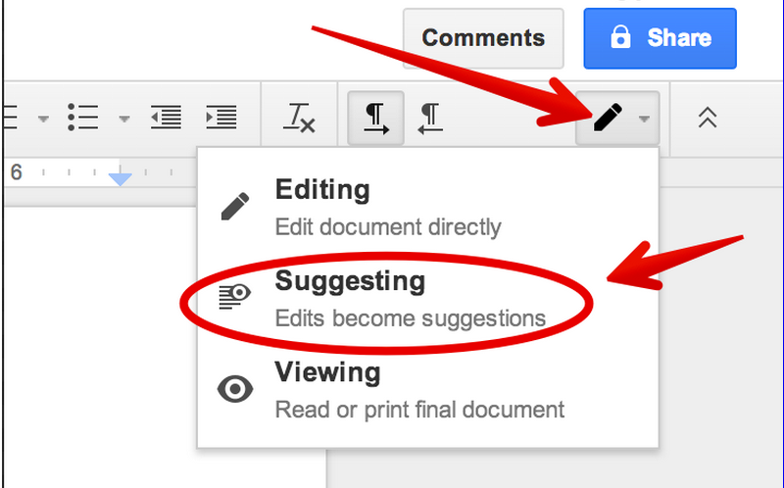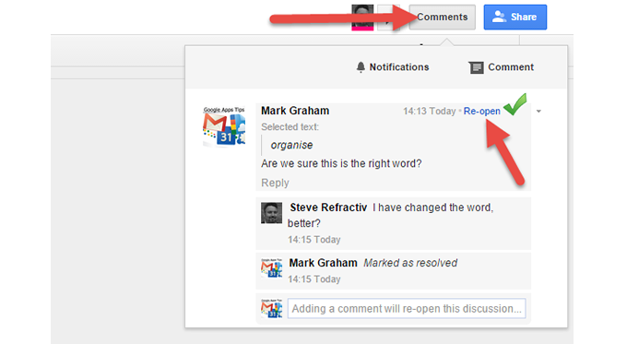

Turning In The Assignment
- Double check to make sure that all group members THAT ARE PRESENT TO WORK ON THE DOCUMENT have their name in the title, and on the document. Students that are absent will make up the assignment at a later time; do NOT list the names of any group members that were not present to contribute.
- Make sure your group’s TEAM COLOR is listed as well.
- Once the group work is completed, the group leader will “TURN IN” the document to Google Classroom. Once you submit changes can no longer be made, so make sure all group members agree before submission.
- The other group members will go into Google Classroom and click on “MARK AS DONE.”



